**WORKING WITH LISTS IN PYTHON**

**Working with Lists**

Now that we know how to create and access list data, we can start to explore additional ways of working with lists.

In this lesson, you’ll learn how to:

* Add and remove items from a list using a specific index.
* Create lists with continuous values.
* Get the length of a list.
* Select portions of a list (called *slicing*).
* Count the number of times that an element appears in a list.
* Sort a list of items.

**Note:** In some of the exercises, we will be using [built-in functions](https://www.codecademy.com/resources/docs/python/built-in-functions?page_req=catalog) in Python. If you haven’t yet explored the concept of a function, it may look a bit new. Below we compare it to the method syntax we learned in the earlier lesson.

Here is a preview:

# Example syntax for methods  
list.method(input)  
   
# Example syntax for a built-in function   
builtinfuncion(input)

**Instructions**

Take a second to preview some of the things we will be learning by examining the graphic of common list methods and built-in functions.

When you’re ready, continue to the next exercise.

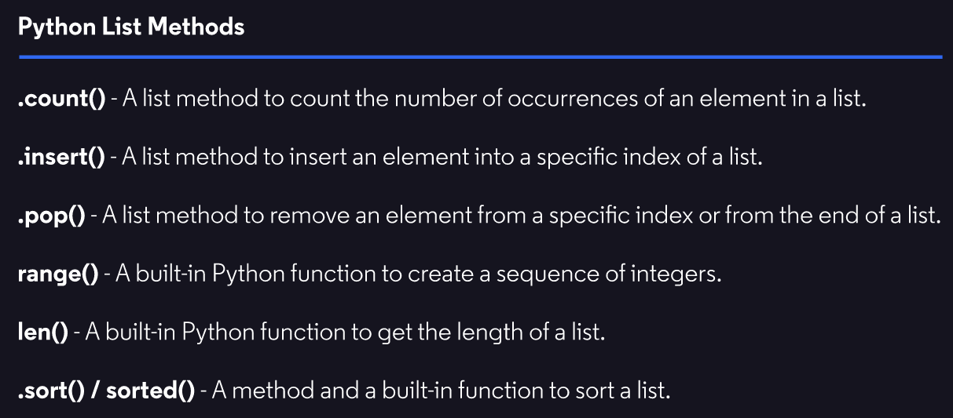

**Adding by Index: Insert**

The Python list method .insert() allows us to add an element to a specific index in a list.

The [.insert()](https://www.codecademy.com/resources/docs/python/lists/insert?page_ref=catalog) method takes in two inputs:

1. The index you want to insert into.
2. The element you want to insert at the specified index.

The .insert() method will handle shifting over elements and can be used with negative indices.

To see it in action let’s imagine we have a list representing a line at a store:

store\_line = ["Karla", "Maxium", "Martim", "Isabella"]

"Maxium" saved a spot for his friend "Vikor" and we need to adjust the list to add him into the line right behind "Maxium".

For this example, we can assume that "Karla" is the front of the line and the rest of the elements are behind her.

Here is how we would use the .insert() method to insert "Vikor" :

store\_line.insert(2, "Vikor")  
print(store\_line)

Would output:

['Karla', 'Maxium', 'Vikor', 'Martim', 'Isabella']

Some important things to note:

1. The order and number of the inputs is important. The .insert() method expects two inputs, the first being a numerical index, followed by any value as the second input.
2. When we insert an element into a list, all elements from the specified index and up to the last index are shifted one index to the right. This does not apply to inserting an element to the very end of a list as it will simply add an additional index and no other elements will need to shift.

Let’s practice using .insert()!

**Instructions**

**1.**

We are helping out a popular grocery store called Jiho’s Produce.

Every week the store has to choose the order in which it displays some of its popular items on sale in the front window to attract customers.

Jiho, the store owner, likes to store the items for the display in a list.

Check out the current display list in our code editor. Click **Run** to print out the list.

Checkpoint 2 Passed

**2.**

Jiho found out some great news! "Pineapple" is back in stock.

Jiho would like to put "Pineapple" in the front of the list so it is the first item customers see in the display window.

Use .insert() to add "Pineapple" to the front of the list.

Print the resulting list to see the change.

***Note***: For this list, the front will be the element at index 0

Checkpoint 3 Passed

Hint

Remember the .insert() method takes in two inputs:

1. The index you want to insert into.
2. The element you want to insert at the specified index.

list.insert(index, element)

**script.py**

front\_display\_list = ["Mango", "Filet Mignon", "Chocolate Milk"]

print(front\_display\_list)

# Your code below:

front\_display\_list.insert(0, 'Pineapple')

print(front\_display\_list)

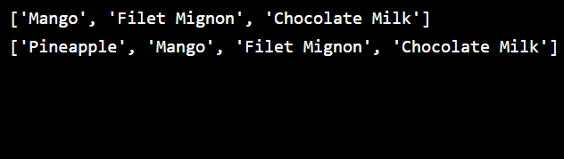

**Removing by Index: Pop**

Just as we learned to insert elements at specific indices, Python gives us a method to remove elements at a specific index using a method called .pop().

The [.pop()](https://www.codecademy.com/resources/docs/python/lists/pop?page_req=catalog) method takes an optional single input:

1. The index for the element you want to remove.

To see it in action, let’s consider a list called cs\_topics that stores a collection of topics one might study in a computer science program.

cs\_topics = ["Python", "Data Structures", "Balloon Making", "Algorithms", "Clowns 101"]

Two of these topics don’t look like they belong, let’s see how we remove them using .pop().

First let’s remove "Clowns 101":

removed\_element = cs\_topics.pop()  
print(cs\_topics)  
print(removed\_element)

Would output:

['Python', 'Data Structures', 'Balloon Making', 'Algorithms']  
'Clowns 101'

Notice two things about this example:

1. The method can be called without a specific index. Using .pop() without an index will remove whatever the last element of the list is. In our case "Clowns 101" gets removed.
2. .pop() is unique in that it will *return* the value that was removed. If we wanted to know what element was deleted, simply assign a variable to the call of the .pop() method. In this case, we assigned it to removed\_element.

Lastly let’s remove "Balloon Making":

cs\_topics.pop(2)  
print(cs\_topics)

Would output:

['Python', 'Data Structures', 'Algorithms']

Notice two things about this example:

1. The method can be called with an optional specific index to remove. In our case, the index 2 removes the value of "Balloon Making".
2. We don’t have to save the removed value to any variable if we don’t care to use it later.

***Note:*** Passing in an index that does not exist or calling .pop() on an empty list will both result in an IndexError.

Let’s apply what we learned about the .pop() method.

**Instructions**

**1.**

We have decided to pursue the study of data science in addition to our computer science coursework. We signed up for an online school that would help us become proficient.

Check out the current list of topics we will be studying in our code editor.

Click ***Run*** to print out the list.

Checkpoint 2 Passed

**2.**

It looks like we have an overlap with our computer science curriculum for the topic of "Python 3".

Let’s remove the topic from the list of data\_science\_topics using our newly learned .pop() method.

Print data\_science\_topics to see your result.

Checkpoint 3 Passed

Hint

Since "Python 3" is the last element in the list we can use the .pop() method with no input between the parenthesis to remove the last element.

**3.**

Looks like there is overlap on the "Algorithms" topic as well. Let’s use .pop() to remove it as well.

Print data\_science\_topics to see the changes.

Checkpoint 4 Passed

Hint

Since "Algorithms" does not live at the end of the list, we need to use .pop() and provide a specific index to the method. For example:

example\_list = [1, 2, 3]  
   
# To remove element `2` we would do:   
example\_list.pop(1)

**script.py**

data\_science\_topics = ["Machine Learning", "SQL", "Pandas", "Algorithms", "Statistics", "Python 3"]

print(data\_science\_topics)

# Your code below:

data\_science\_topics.pop()

print(data\_science\_topics)

data\_science\_topics.pop(3)

print(data\_science\_topics)

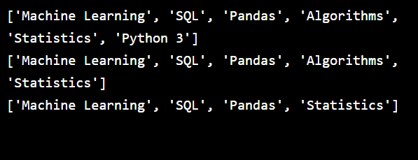

**Consecutive Lists: Range**

Often, we want to create a list of consecutive numbers in our programs. For example, suppose we want a list containing the numbers 0 through 9:

my\_list = [0, 1, 2, 3, 4, 5, 6, 7, 8, 9]

Typing out all of those numbers takes time and the more numbers we type, the more likely it is that we have a typo that can cause an error.

Python gives us an easy way of creating these types of lists using a built-in function called [range()](https://www.codecademy.com/resources/docs/python/built-in-functions/range?page_req=catalog).

The function range() takes a single input, and generates numbers starting at 0 and ending at the number **before** the input.

So, if we want the numbers from 0 through 9, we use range(10) because 10 is 1 greater than 9:

my\_range = range(10)  
print(my\_range)

Would output:

range(0, 10)

Notice something different? The range() function is unique in that it creates a *range object*. It is not a typical list like the ones we have been working with.

In order to use this object as a list, we have to first convert it using another built-in function called [list()](https://www.codecademy.com/resources/docs/python/built-in-functions/list?page_ref=catalog).

The list() function takes in a single input for the object you want to convert.

We use the list() function on our range object like this:

print(list(my\_range))

Would output:

[0, 1, 2, 3, 4, 5, 6, 7, 8, 9]

Let’s try out using range()!

**Instructions**

**1.**

Modify number\_list so that it is a range containing numbers starting at 0 and up to, but not including, 9.

Checkpoint 2 Passed

Hint

Remember the range is non-inclusive of the input number.

If we wanted to generate a range from 0 to 7 we would do:

range(8)

**2.**

Create a range called zero\_to\_seven with the numbers 0 through 7.

Print the result in list form.

Checkpoint 3 Passed

Hint

Don’t forget to convert the range object to a list using the built-in function list(). Here is an example:

print(list(my\_range))

**script.py**

# Your code below:

number\_list = range(9)

print(list(number\_list))

zero\_to\_seven = range(8)

print(list(zero\_to\_seven))

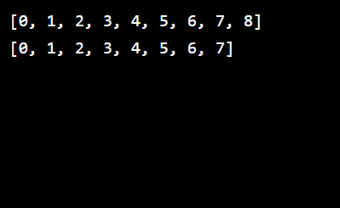

**The Power of Range!**

By default, range() creates a list starting at 0. However, if we call range() with two inputs, we can create a list that starts at a different number.

For example, range(2, 9) would generate numbers starting at 2 and ending at 8 (just before 9):

my\_list = range(2, 9)  
print(list(my\_list))

Would output:

[2, 3, 4, 5, 6, 7, 8]

If we use a third input, we can create a list that “skips” numbers.

For example, range(2, 9, 2) will give us a list where each number is 2 greater than the previous number:

my\_range2 = range(2, 9, 2)  
print(list(my\_range2))

Would output:

[2, 4, 6, 8]

We can skip as many numbers as we want!

For example, we’ll start at 1 and skip in increments of 10 between each number until we get to 99 (one before 100):

my\_range3 = range(1, 100, 10)  
print(list(my\_range3))

Would output:

[1, 11, 21, 31, 41, 51, 61, 71, 81, 91]

Our list stops at 91 because the next number in the sequence would be 101, which is greater than or equal to 100 (our stopping point).

Let’s experiment with our additional range() inputs!

**Instructions**

**1.**

Modify the range() function that created the range range\_five\_three such that it:

* Starts at 5
* Has a difference of 3 between each item
* Ends **before** 15

Checkpoint 2 Passed

Hint

Right now our range(5, 15, 2) goes up by steps of 2. Modify the third input to satisfy the checkpoint.

**2.**

Create a range called range\_diff\_five that:

* Starts at 0
* Has a difference of 5 between each item
* Ends **before** 40

Checkpoint 3 Passed

Hint

Remember the input positions for the range function and what they represent. For example:

range(0, 5, 2)

1. The first input represents the starting point. Here that is represented by 0
2. The second input represents the ending point. Here that is represented by 5
3. The third input represents in what increments the range will skip as it approaches the ending point. Here that is represented by 2

**script.py**

# Your code below:

range\_five\_three = range(5, 15, 3)

print(list(range\_five\_three))

range\_diff\_five = range(0, 40, 5)

print(list(range\_diff\_five))

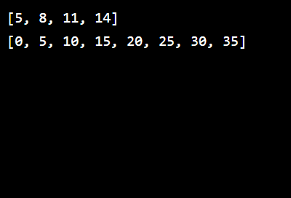

**Length**

Often, we’ll need to find the number of items in a list, usually called its *length*.

We can do this using a built-in function called [len()](https://www.codecademy.com/resources/docs/python/built-in-functions/len?page_ref=catalog" \t "_blank).

When we apply len() to a list, we get the number of elements in that list:

my\_list = [1, 2, 3, 4, 5]  
   
print(len(my\_list))

Would output:

5

Let’s find the length of various lists!

**Instructions**

**1.**

Calculate the length of long\_list and save it to the variable long\_list\_len.

Checkpoint 2 Passed

Hint

To use the len() built-in function, pass a list in between the parenthesis ( )

example\_list = [1, 5, "Item"]  
list\_length = len(example\_list)

**2.**

Use print() to examine long\_list\_len.

Checkpoint 3 Passed

Hint

Your output should be 18.

**3.**

We have provided a completed range() function for the variable big\_range.

Calculate its length using the function len() and save it to a variable called big\_range\_length.

***Note:*** Range objects do not need to be converted to lists in order to determine their length

Checkpoint 4 Passed

Hint

We can use the len() function to calculate a range’s length.

# Generates a range of (0, 5)    
my\_range = range(0, 10, 5)  
   
length\_of\_range = len(my\_range)

**4.**

Use print() to examine big\_range\_length.

Checkpoint 5 Passed

Hint

Your output should be 300

**5.**

Change the range() function that generates big\_range so that it skips 100 instead of 10 steps between items.

How does this change big\_range\_length?

Checkpoint 6 Passed

Hint

Changing the third input of a range changes how many elements we skip and thus changing the length of the list. For example:

# The list would be [0, 2, 4, 6, 8] with length 5  
range(0, 10, 2)  
   
# The list would be [0, 3, 6, 9] with length 4  
range(0, 10, 3)

**script.py**

long\_list = [1, 5, 6, 7, -23, 69.5, True, "very", "long", "list", "that", "keeps", "going.", "Let's", "practice", "getting", "the", "length"]

big\_range = range(2, 3000, 100)

# Your code below:

long\_list\_len = len(long\_list)

print(long\_list\_len)

big\_range\_length = len(big\_range)

print(big\_range\_length)

**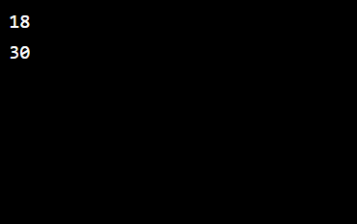**

**Slicing Lists I**

In Python, often we want to extract only a portion of a list. Dividing a list in such a manner is referred to as *slicing*.

Lets assume we have a list of letters:

letters = ["a", "b", "c", "d", "e", "f", "g"]

Suppose we want to select from "b" through "f".

We can do this using the following syntax: letters[start:end], where:

* start is the index of the first element that we want to include in our selection. In this case, we want to start at "b", which has index 1.
* end is the index of *one more than* the last index that we want to include. The last element we want is "f", which has index 5, so end needs to be 6.

sliced\_list = letters[1:6]  
print(sliced\_list)

Would output:

["b", "c", "d", "e", "f"]

Notice that the element at index 6 (which is "g") is *not* included in our selection.

**Instructions**

**1.**

Use print() to examine the variable beginning.

Before hitting ***Run*** think about what elements beginning will contain?

Checkpoint 2 Passed

**2.**

Modify beginning, so that it selects the first 2 elements of suitcase.

Checkpoint 3 Passed

Hint

We are looking for the first two elements of our list. This means we want to start at the first element with index 0 and end right after the second element with index 1.

Remember the ending of our slice is the index of *one more than* the last index that we want to include. For example:

elements = [1, 2, 3, 4, 5]  
slice = elements[0:3]  
print(slice)

Would output the first 3 elements since index 3 is not included:

[1, 2, 3]

**3.**

Create a new list called middle that contains the middle two items ( ["pants", "pants"] ) from suitcase.

Print middle to see the slice!

Checkpoint 4 Passed

Hint

There are 6 items in suitcase, which means its elements start at index 0 and end at index 5.

The middle two elements are located at index 2 and 3, so we want items starting at index 2 and up to, but not including, index 4.

**script.py**

suitcase = ["shirt", "shirt", "pants", "pants", "pajamas", "books"]

beginning = suitcase[0:4]

# Your code below:

print(beginning)

beginning = suitcase[0:2]

middle = suitcase[2:4]

print(middle)

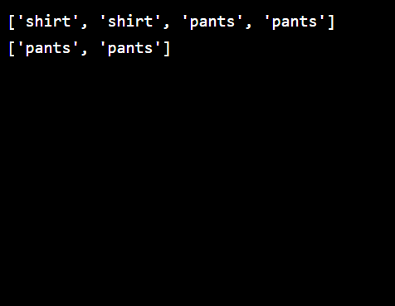

**Slicing Lists II**

Slicing syntax in Python is very flexible. Let’s look at a few more problems we can tackle with slicing.

Take the list fruits as our example:

fruits = ["apple", "cherry", "pineapple", "orange", "mango"]

If we want to select the *first n elements* of a list, we could use the following code:

fruits[:n]

For our fruits list, suppose we wanted to slice the first three elements.

The following code would start slicing from index 0 and up to index 3. Note that the fruit at index 3 (orange) is not included in the results.

print(fruits[:3])

Would output:

['apple', 'cherry', 'pineapple']

We can do something similar when we want to slice the *last n elements* in a list:

fruits[-n:]

For our fruits list, suppose we wanted to slice the last two elements.

This code slices from the element at index -2 up through the last index.

print(fruits[-2:])

Would output:

['orange', 'mango']

Negative indices can also accomplish taking *all but n last elements* of a list.

fruits[:-n]

For our fruits example, suppose we wanted to slice all but the last element from the list.

This example starts counting from the 0 index up to the element at index -1.

print(fruits[:-1])

Would output:

['apple', 'cherry', 'pineapple', 'orange']

Let’s practice some of these extra slicing techniques!

**Instructions**

**1.**

Create a new list called last\_two\_elements containing the final two elements of suitcase.

Print last\_two\_elements to see your result.

Checkpoint 2 Passed

Hint

To slice the *last n elements* in a list:

fruits[-n:]

If we want to slice off the last two elements, what would n be?

**2.**

Create a new list called slice\_off\_last\_three containing all but the last three elements.

Print slice\_off\_last\_three to see your result.

Checkpoint 3 Passed

Hint

Negative indices can help accomplish taking *all but n last elements* of a list.

fruits[:-n]

If we want a slice containing all but the last three elements, what would n be?

**script.py**

suitcase = ["shirt", "shirt", "pants", "pants", "pajamas", "books"]

# Your code below:

last\_two\_elements = suitcase[-2:]

print(last\_two\_elements)

slice\_off\_last\_three = suitcase[:-3]

print(slice\_off\_last\_three)

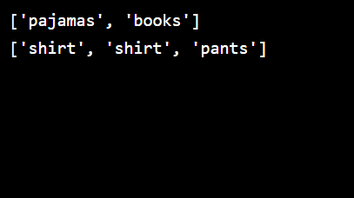

**Counting in a List**

In Python, it is common to want to count occurrences of an item in a list.

Suppose we have a list called letters that represents the letters in the word “Mississippi”:

letters = ["m", "i", "s", "s", "i", "s", "s", "i", "p", "p", "i"]

If we want to know how many times i appears in this word, we can use the list method called [.count()](https://www.codecademy.com/resources/docs/python/lists/count?page_req=catalog):

num\_i = letters.count("i")  
print(num\_i)

Would output:

4

Notice that since .count() *returns* a value, we can assign it to a variable to use it.

We can even use .count() to count element appearances in a two-dimensional list.

Let’s use the list number\_collection as an example:

number\_collection = [[100, 200], [100, 200], [475, 29], [34, 34]]

If we wanted to know how often the sublist [100, 200] appears:

num\_pairs = number\_collection.count([100, 200])  
print(num\_pairs)

Would output:

2

Let’s count some list items using the .count() method!

**Instructions**

**1.**

Mrs. Wilson’s class is voting for class president. She has saved each student’s vote into the list votes.

Use .count() to determine how many students voted for "Jake" and save the value to a variable called jake\_votes.

Checkpoint 2 Passed

Hint

If we wanted to know how many students voted for "Laurie", we’d use:

votes.count("Laurie")

**2.**

Use print() to examine jake\_votes.

**script.py**

votes = ["Jake", "Jake", "Laurie", "Laurie", "Laurie", "Jake", "Jake", "Jake", "Laurie", "Cassie", "Cassie", "Jake", "Jake", "Cassie", "Laurie", "Cassie", "Jake", "Jake", "Cassie", "Laurie"]

# Your code below:

jake\_votes = votes.count("Jake")

print(jake\_votes)

**script.py**

votes = ["Jake", "Jake", "Laurie", "Laurie", "Laurie", "Jake", "Jake", "Jake", "Laurie", "Cassie", "Cassie", "Jake", "Jake", "Cassie", "Laurie", "Cassie", "Jake", "Jake", "Cassie", "Laurie"]

# Your code below:

jake\_votes = votes.count("Jake")

print(jake\_votes)

**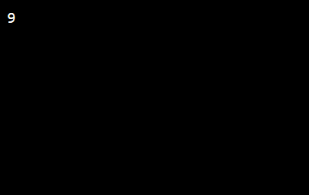**

**Sorting Lists I**

Often, we will want to sort a list in either numerical (1, 2, 3, …) or alphabetical (a, b, c, …) order.

We can sort a list using the method [.sort()](https://www.codecademy.com/resources/docs/python/lists/sort?page_req=catalog).

Suppose that we have a list of names:

names = ["Xander", "Buffy", "Angel", "Willow", "Giles"]

Let’s see what happens when we apply .sort():

names.sort()  
print(names)

Would output:

['Angel', 'Buffy', 'Giles', 'Willow', 'Xander']

As we can see, the .sort() method sorted our list of names in alphabetical order.

.sort() also provides us the option to go in reverse. Instead of sorting in ascending order like we just saw, we can do so in descending order.

names.sort(reverse=True)  
print(names)

Would output:

['Xander', 'Willow', 'Giles', 'Buffy', 'Angel']

**Note:** The .sort() method does not return any value and thus does not need to be assigned to a variable since it modifies the list directly. If we do assign the result of the method, it would assign the value of None to the variable.

Let’s experiment sorting various lists!

**Instructions**

**1.**

Use .sort() to sort addresses.

Checkpoint 2 Passed

Hint

Like with any list method, attach the method to the list you want to apply it on.

list.sort()

**2.**

Use print() to see how addresses changed.

Checkpoint 3 Passed

**3.**

Remove the # and whitespace in front of the line sort(names). Edit this line so that it runs without producing a NameError.

Checkpoint 4 Passed

Hint

Remember, sort comes *after* the list:

my\_list.sort()

If you receive an IndentationError make sure to check you removed the whitespace after the #.

**4.**

Use print to examine sorted\_cities. Why is it not the sorted version of cities?

Checkpoint 5 Passed

Hint

The .sort() method does not return any value and thus does not need to be assigned to a variable. This is why we will see the value of None as our output for sorted\_cities

**5.**

Edit the .sort() call on cities such that it sorts the cities in reverse order (descending).

Print cities to see the result.

Checkpoint 6 Passed

Hint

To reverse a list using .sort(), add an optional input keyword argument and assign it the value of True.

list.sort(reverse=True)

**script.py**

# Checkpoint 1 & 2

addresses = ["221 B Baker St.", "42 Wallaby Way", "12 Grimmauld Place", "742 Evergreen Terrace", "1600 Pennsylvania Ave", "10 Downing St."]

addresses.sort()

print(addresses)

# Checkpoint 3

names = ["Ron", "Hermione", "Harry", "Albus", "Sirius"]

names.sort()

# Checkpoint 4 & 5

cities = ["London", "Paris", "Rome", "Los Angeles", "New York"]

sorted\_cities = cities.sort(reverse=True)

print(sorted\_cities)

**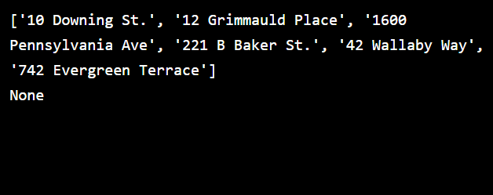**

**Sorting Lists II**

A second way of sorting a list in Python is to use the built-in function sorted().

The [sorted()](https://www.codecademy.com/resources/docs/python/built-in-functions/sorted?page_req=catalog) function is different from the .sort() method in two ways:

1. It comes *before* a list, instead of after as all built-in functions do.
2. It generates a new list rather than modifying the one that already exists.

Let’s return to our list of names:

names = ["Xander", "Buffy", "Angel", "Willow", "Giles"]

Using sorted(), we can create a new list, called sorted\_names:

sorted\_names = sorted(names)  
print(sorted\_names)

This yields the list sorted alphabetically:

['Angel', 'Buffy', 'Giles', 'Willow', 'Xander']

Note that using sorted did not change names:

print(names)

Would output:

['Xander', 'Buffy', 'Angel', 'Willow', 'Giles']

**Instructions**

**1.**

Use sorted() to order games and create a new list called games\_sorted.

Checkpoint 2 Passed

Hint

As with any built-in function, pass the list you wish to be sorted in between the parenthesis ( ) of the function.

sorted(list)

**2.**

Print both games and games\_sorted. How are they different?

Checkpoint 3 Passed

Hint

In contrast to the method .sort(), the built-in function sorted() will not modify the original list.

**script.py**

games = ["Portal", "Minecraft", "Pacman", "Tetris", "The Sims", "Pokemon"]

# Your code below:

games\_sorted = sorted(games)

print(games)

print(games\_sorted)

**